

***Personal Consultation Services***

**Developed by:** Ganesh Pandi E

**Reg No:** R200002100293

**Batch Code:** 210167

**Name of the Cordinator:** Ms. Lopamudra Bera

**Date of Submission:** 12/12/2020

***CERTIFICATE***

This is to certify that “Ganesh Pandi E” student of Batch-S210167 has successfully completed their Project on “Professional Consultancy Services” under the guidance of “Miss.Lopamudra Bera”.

Miss.Lopmudra Bera Ganesh Pandi E

***ACKNOWLEDGEMENT***

I would like to express my special thanks of gratitude to my teacher

“Miss.Lopamudra Bera” for their able guidance and support in completing my Project.

Date: Ganesh Pandi E

12/12/2020  R200002100293

***ABSTRACT***

This Project will mainly use for professional networking, allowing registered employees to post jobs and their information is organized and easily accessible to all registered users such as job seekers, employers and HR consultant.

Users will register themselves in the application and fill in their professional details along with their core competencies. And Employers can be able to search relevant profiles for their openings using the keywords that matches with the profiles. Based on the match, relevant profiles should be shown to the employers with their contact details and International Business Unit name.

|  |  |
| --- | --- |
| ***CONFIGURATION***   |  | | --- | | * Hardware   + - Core i3 Processor 2.10 GHz x64 bit     - 8 Gigabytes of RAM * Operating System   + - Windows 10 Home * Software   + Eclipse IDE     - JAVA     - *MYSQL* | |

***OBJECTIVE***

This Project will mainly use for professional networking, allowing registered employees to post jobs and their information is organized and easily accessible to all registered users such as job seekers, employers and HR consultant.

Users will register themselves in the application and fill in their professional details along with their core competencies. And Employers can be able to search relevant profiles for their openings using the keywords that matches with the profiles. Based on the match, relevant profiles should be shown to the employers with their contact details and International Business Unit name.

***CASE STUDY***

Professionet Consultancy Services (PCS) is a business consultancy that has established itself as a renowned service provider of a wide range of business services to its clients.

PCS offers an offline platform for their employees to share their profiles to initiate internal job posting process with the expert Human Resources consultants.

There are over 22,000 new and 50,000 experienced PCS professionals providing their services to 150 clients aligned with the consultancy. The consultancy needs to maintain the information of every PCS employee focusing on their industry vertical. All PCS employees are registered with PCS and are given a unique identification number. Profile validation is done by the HR experts and requirements are full filled by mapping skills and requirements manually.

The Consultancy wants to introduce automation in their Internal Job Posting (IJP) selection and recruitment process so that the potential PCS employees and HR department have an online platform based on a skill map engine to connect directly with each other and aid their job search within the company. HR and PM can also post their jobs and refine their search by using keywords that matches the profiles.

***STATEMENT OF REQUIREMENTS***

**Key Features of the application:**

* Skill mappingfeature is the most prominent feature of this software that will reduce time and effort spent on profile screening and mapping the employees’ profiles with the current business requirement.
* Also this software holds the other features such as having a separate window for Employees, Project Managers and HR’s to access their portal.
* It has the registration window to register with the company by themselves.
* Application has the same login window for everyone and it detects by itself which designation you are in and give access accordingly.
* HR can able to activate and deactivate an employee’s profile and recruit an employee to their organization.
* HR can able to view all the employee’s status and can add, delete, activate or deactivate a skill in the portal.
* Project Manager can add a job on the portal and deactivate or activate a job while it is needed.
* PM can also monitor the employees who has applied for the posted job on the portal and also sort out the jobs using particular skill name.
* Employee will have access to view and update their profile anytime and can see what the available jobs on their required verticals are.
* They can apply for the jobs by mentioning the job id that will immediately reflect on the HR’s portal.

**PM**

* Activate or Deactivate Employee
* View All Employee
* View Selective Employee
* Add Skill
* View All Skill
* Activate or Deactivate Skill
* Add and Update Job
* Activate or Deactivate a Job
* View All Job
* View Any Employee Profile
* View Employee Who Apply For Job

HR

EMP

In the above model is that the overall functionality model of the application that we have already discussed in the previous chapter.

***HIGH LEVEL CASE DIAGRAM***

**HR**

**Discussing the needed** skills

**Screening and recruiting**

**JOB POSTING**

**EMP**

**PME**

**DATABASE**

**MYSQL**

A High-level design document adds the necessary details to the current project description to represent a suitable model for coding.

***LOW LEVEL CASE DIAGRAM***

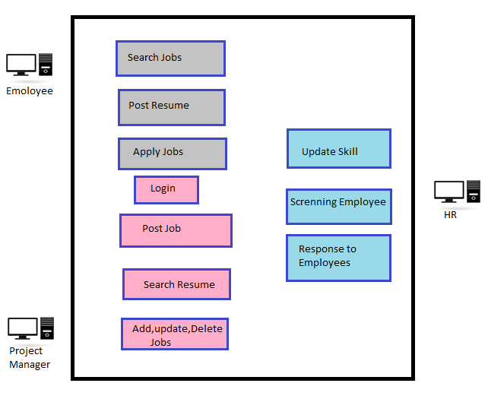

Here is the Low level case diagram which represents everything a user can do. An Employee can search for a job, update their profile and apply for a job.

Project Manager can post the job necessary for the organization and monitor the cycle. He can able to activate and deactivate a job according to the situation of the company. Similarly, HR can monitor the profiles who are applied for the particular jobs and screening them by matching the skill sets to pick a suitable employee to fit the project.

***USER INTERFACE DESIGN***

The common user interface for the entire system that includes an Employee, Project Manager and HR.

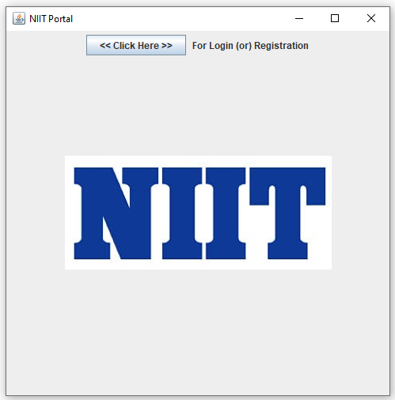

The user has to be Click “Clcik Here” button before login or registered.

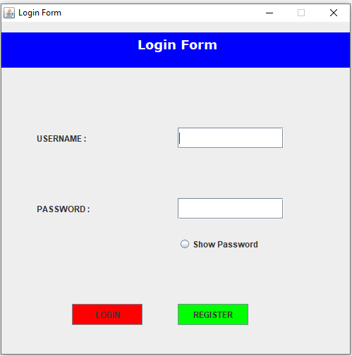

User must fill the Text field before click login (or) it will thorw error message.

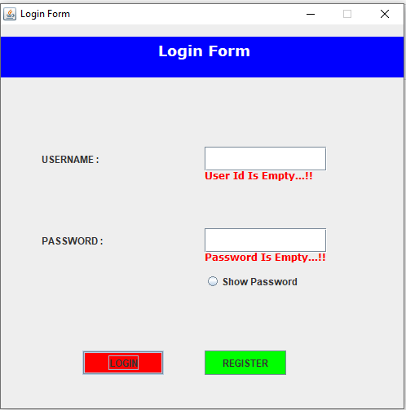

The above snap explains must fill the textfield before click login.

The user has to be registered as Professional Consultancy Services Employee before login. This frame will connect to the database and checks the user’s authorization and then also set which designation they belong to Employee Window, PME Window, HR Window and then will give access to the user . If user doesn’t have authorization for login then user has to click “REGISTER” button for Registration.

This is the Registration form that the user has to fill their details to get registered with the Professional Consultancy Services.

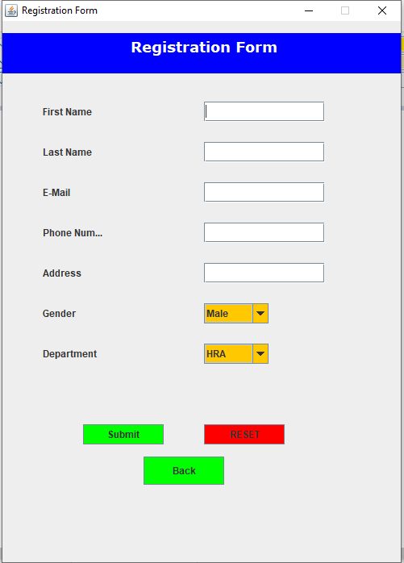

The System must not miss out any kind of information while dealing with the registration form. So, the authentication is very much important for the organization. The registration form would check each and every column for null value and alert the user to fill that missing field and also it makes sure that the entered all textbox without miss any textbox.

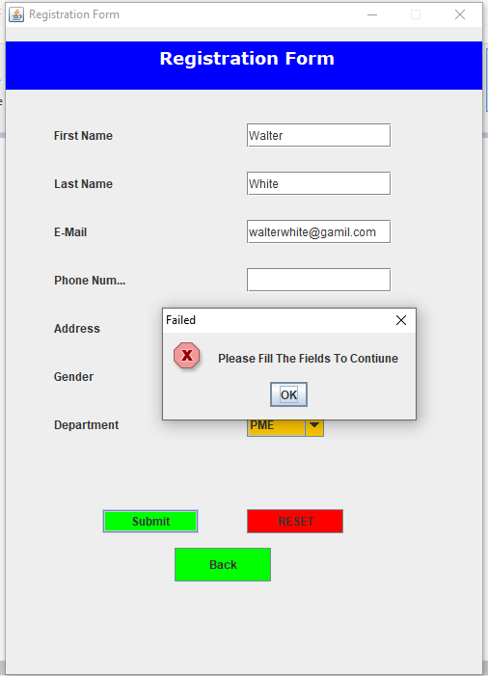

In above snap Phone Num textbox is missed to fill and if you clicked Submit button .It will throw error message and fill the required field to complete registration.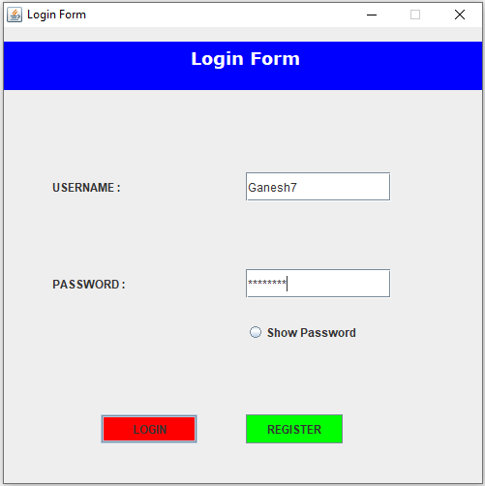

This is how a user can login to their portal. This is a HR login credentials. This navigates us to HR portal. While registering with the portal, one need to choose that the user is which an Employee / Project Manager / HR .It will walk us through which portal we are having the access to.

HR Window Screen:-

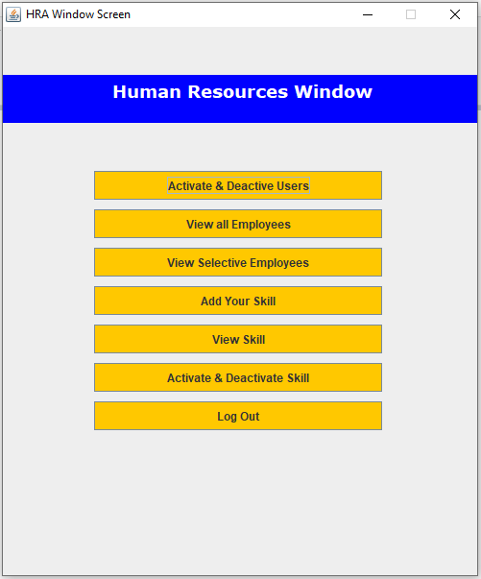

This is how the HR Window looks like. Here, can see that what HR can have the access to do.

HR can

* Activate or deactivate Users
* View all employees
* View Selective Employee
* Add Your skill
* View all available skills in the database
* Activate, deactivate Skill.

HR Can to Activate or deactivate Employee/Skill with Employee ID/Skill ID

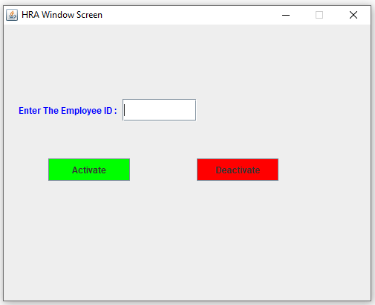 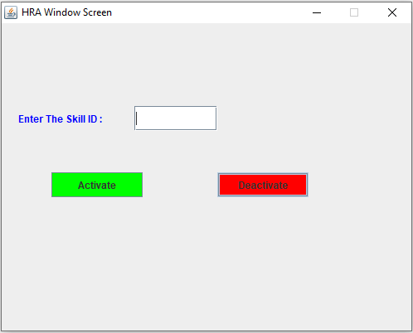

HR can see all the Employee/skills that includes to see deactivated Employee/Skills to check the data



All Employee Details:-

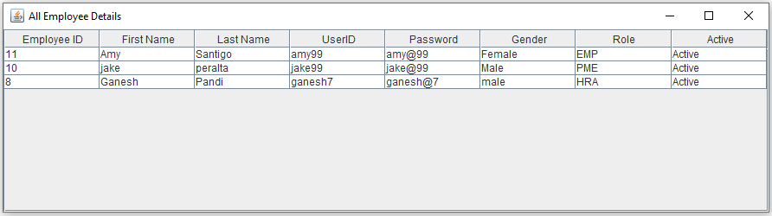

All Skill Details:-

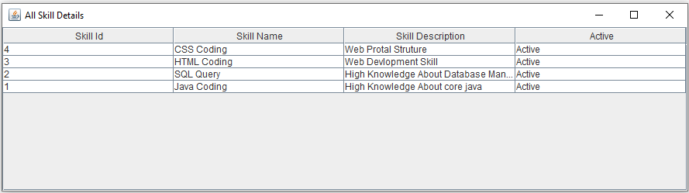

HR Can able to see a particular selective employee’s details with Employee ID



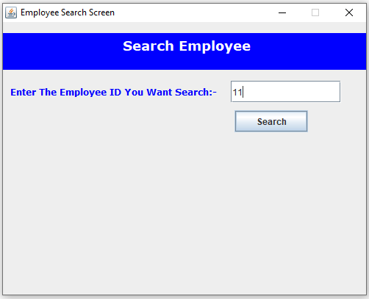

After enter Employee ID click the Search button then HR can see a particular employee details.

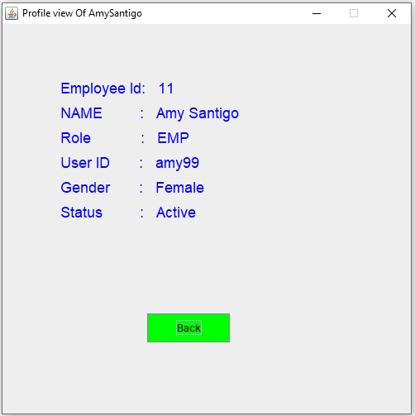

Above snap explain how the view selective employee profile

HR can able to add a skill.

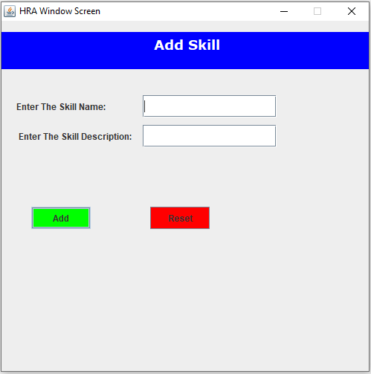

HR can able to add the skill by entering the skill name and the skill description. It will updated to database and application.